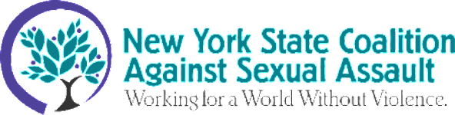

NYSCASA invites you to our Annual Membership Meeting on June 23rd from 1:00 pm-5:00 pm. We are pleased to host this in-person meeting at the Hudson Candy Factory, located in Troy, New York.
To attend the annual meeting, registration is required. Click HERE to register via Eventbrite. The cost of attendance is $30 per person and includes lunch. Registration ends on June 3rd or until capacity is reached.
Whether you can or cannot join us, we ask that regular members review and vote for the upcoming board slate and the proposed revisions to the by-laws by noon on June 22nd. Each member rape crisis program in good standing is allowed one vote. Should you have any questions please contact: Mani V. McCalmon (imccalmon@nyscasa.org)
Program: Our theme this year is Building Solidarity to End Sexual Violence
The NYSCASA Board of Directors will lead the business aspects of the meeting. We will hear from Luz Márquez Benbow, the newly appointed Executive Director as she looks to the future of coalition building across NYS.
We will host a critical conversation, Our Bodies Are More Than Just A Crime Scene: focused on the health aftermath of sexual assault. This discussion will highlight DIY rape kits, and include a District Attorney, SANE Nurse, and perspectives from survivors and college representatives.
Join us for this rich conversation.
Hotel Information:
For those requiring hotel accommodations, we have a block of rooms reserved at the Hilton Garden Inn in Troy. Use this link to register for hotel accommodations

NYSCASA Annual Meeting Committee Co-Chairs
Kelly Scott-Conroy/Janice Brown

